Linear Integrated Circuits and Applications
(UEC512)
Experiment No. – 12
To study & analyze the working of Operational Amplifier IC 741 as a Zero Crossing Detector
Submitted by:
Ansh Bansal (Group Leader) | (1024060032)
Hardaksh Singh Sabharwal | (1024060029)
Siddharth Kumar | (1024060019)
Yashika Kumari | (1024060031)

Submitted to:
Mr. Chhabilal Singh Sir


Department Of Electronics and Communication Engineering Thapar Institute of Engineering & Technology, Patiala, Punjab, India
Session: July - December, 2026

AIM: To study & analyze the working of Operational Amplifier IC 741 as a Zero Crossing Detector.
APPARATUS REQUIRED:
- IC 741
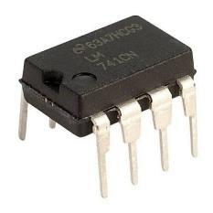
- Resistors – 1 kΩ (R₁, R₂) and 10 kΩ (R_{L})
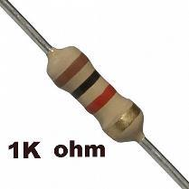 | 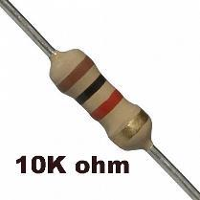
- Bread Board
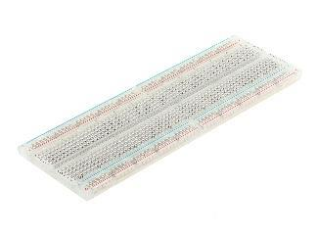
- Jumper wires
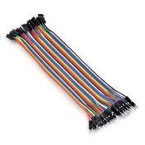
- Function Generator – Tektronix, DSO – Siglent with probes and DC power supply – Rigol (0–30 V). LTspice was used for circuit simulation.
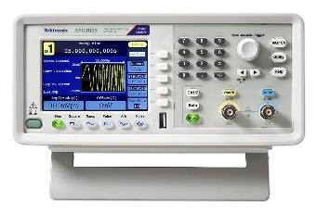 | 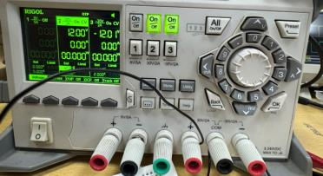

THEORETICAL BACKGROUND AND WORKING:
A zero crossing detector (ZCD) is a special case of the op-amp comparator in which the reference voltage is fixed at V_{ref} = 0 V. It detects the instant at which an input signal crosses zero volts and converts a sinusoidal (or any time-varying) input into a square wave whose transitions occur at the zero crossings of the input. The op-amp is used in open-loop mode, i.e. without any feedback.
In the circuit of Fig. 12.1, the input signal V_{in} is applied through resistor R₁ to the non-inverting input (pin 3) of IC 741, while the inverting input (pin 2) is connected to ground through resistor R₂, which sets the reference at 0 V. R₁ and R₂ limit the input current and balance the input bias currents. The output is taken from pin 6 across the load resistor R_{L} = 10 kΩ.
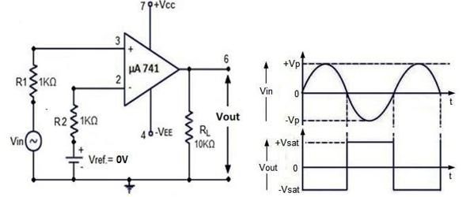
Fig. 12.1 Op-Amp IC 741 as Zero Crossing Detector with Input/Output waveforms
Since there is no feedback, the output is the open-loop gain A_{OL} times the differential input voltage:
V_{out} = A_{OL} (V_{in} − V_{ref}) (1)
With V_{ref} = 0 V, this becomes:
V_{out} = A_{OL} · V_{in} (2)
Because A_{OL} of IC 741 is very large (typically 2 × 10⁵), even a very small input drives the output into saturation:
V_{out} = +V_{sat} for V_{in} > 0 ; V_{out} = −V_{sat} for V_{in} < 0 (3)
The smallest input that drives the output fully into saturation is:
V_{in(min)} = V_{sat} / A_{OL} (4)
Hence, during the positive half-cycle of a sine wave the output stays at +V_{sat}, and during the negative half-cycle it stays at −V_{sat}. The output changes state each time the input crosses zero, so its period equals that of the input. The saturation levels are set by the supply voltages and the output stage of IC 741 and are typically 1–2 V less than the supply rails. In practice the switching point may shift slightly from zero because of the input offset voltage, and the output edges are not perfectly vertical because of the finite slew rate of IC 741 (0.5 V/µs).

PROCEDURE
- Connect the components on the breadboard as shown in Fig. 12.1 and keep all the equipment in “OFF” condition.
- Connect the input signal (V_{in}) from the function generator to the non-inverting input (pin No. 3 of the IC) through R₁ with a BNC cable. Connect the inverting input (pin No. 2) to ground through R₂ so that V_{ref} = 0 V.
- Set the DC power supply to +12 V & −12 V and switch it “OFF”. Now connect +12 V to pin No. 7 and −12 V to pin No. 4 of the IC. Connect the ground terminal of the power supply to the breadboard through a jumper wire.
- For measurement of the output signal, connect one channel of the DSO to pin No. 6 (output pin, across R_{L}) of the IC, and for measurement of the input signal, connect the other channel of the DSO to the input side of the circuit with BNC cables.
- Switch “ON” the function generator & DSO. After some time, switch “ON” the DC power supply. Now apply a sine wave of 4 Vpp amplitude and 1 kHz frequency from the function generator.
- Carefully observe the output against the input signal on the DSO, note the positive and negative saturation voltages, and draw these waveforms on graph paper.
- Repeat the above steps by changing the amplitude and frequency of the input signal and observe the effect on the output.
CIRCUIT SETUP:
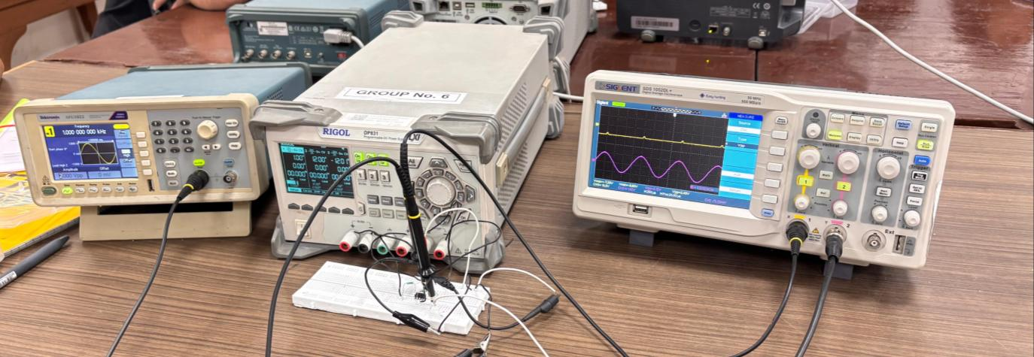
Fig. 12.2 Complete experimental setup

EQUIPMENT SETTINGS:
- DC power supply: +12 V and −12 V (dual supply for IC 741).
- Function generator: sine wave, 4 Vpp, 1 kHz, offset 0 V.
- DSO: CH1 (output) 10.0 V/div, CH2 (input) 2.00 V/div, time base 250 µs/div.
OUTPUTS:
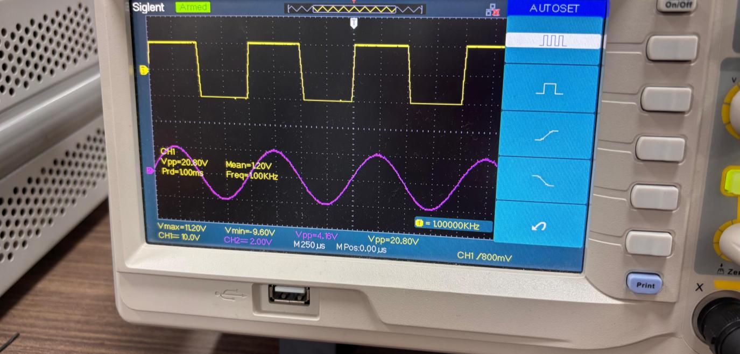
Fig. 12.3 DSO display: input sine wave (CH2, purple) and output square wave (CH1, yellow)

OBSERVATION TABLE
Input: sine wave, V_{ref} = 0 V; R₁ = R₂ = 1 kΩ, R_{L} = 10 kΩ; supply ±12 V
Sr. No. | Input Frequency (Hz) | Vin (Vpp) | Vref | VOUT (Vpp) | +Vsat | −Vsat | Observed output waveform
1 | 1000 (1.00 kHz on DSO) | 4 V (4.16 V on DSO) | 0 V | 20.80 V | +11.20 V | −9.60 V | Square wave switching at each zero crossing of input
DSO readings from Fig. 12.3: CH1 (output) Vpp = 20.80 V, Vmax = 11.20 V, Vmin = −9.60 V, Mean = 1.20 V, Period = 1.00 ms, Frequency = 1.00 kHz; CH2 (input) Vpp = 4.16 V. Scales: CH1 10.0 V/div, CH2 2.00 V/div, time base 250 µs/div.
CALCULATIONS
1. TIME PERIOD AND INPUT PEAK
Given: V_{in(pp)} = 4 V ; V_{ref} = 0 V ; f = 1 kHz
T = 1/f = 1/1000 = 1 ms (matches Prd = 1.00 ms on the DSO)
V_{in(p)} = V_{in(pp)} / 2 = 4 / 2 = 2 V
2. OUTPUT PEAK-TO-PEAK VOLTAGE
V_{out(pp)} = V_{max} − V_{min} = 11.20 − (−9.60) = 20.80 V
+V_{sat} = +11.20 V (0.80 V below +12 V) ; −V_{sat} = −9.60 V (2.40 V below −12 V). The output of IC 741 cannot swing up to the supply rails, and its negative swing is smaller than its positive swing, which explains the unequal saturation levels.
3. MINIMUM INPUT FOR SWITCHING
From Eq. (4), with A_{OL} ≈ 2 × 10⁵:
V_{in(min)} = 11.20 / (2 × 10⁵) ≈ 56 µV
This is negligible compared with the 2 V input peak, so the output switches practically at the zero crossings of the input.
4. TRANSITION TIME (SLEW-RATE LIMIT)
With slew rate SR = 0.5 V/µs for IC 741:
t_{transition} = V_{out(pp)} / SR = 20.80 / 0.5 ≈ 41.6 µs
This is about 4.2 % of the 1 ms period, which is why the edges of the output square wave appear slightly sloped on the DSO. For an ideal 50 % duty cycle the mean output would be (11.20 − 9.60)/2 = 0.80 V; the measured mean of 1.20 V is close to this, the small difference being due to input offset voltage and the finite edge slope.

LTSPICE SIMULATION:
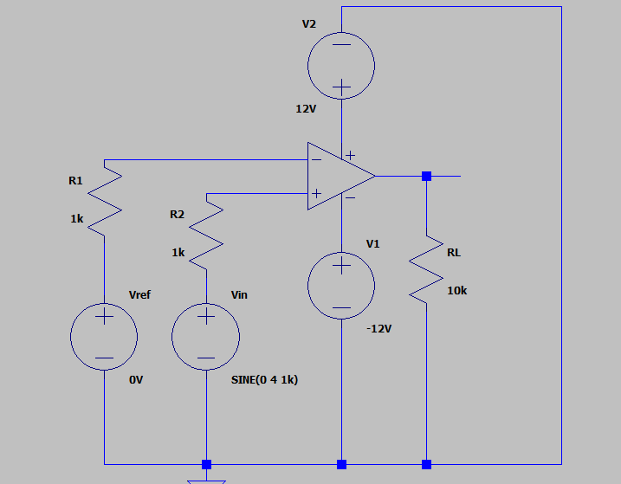
Fig. 12.4 LTspice simulation circuit of the zero crossing detector
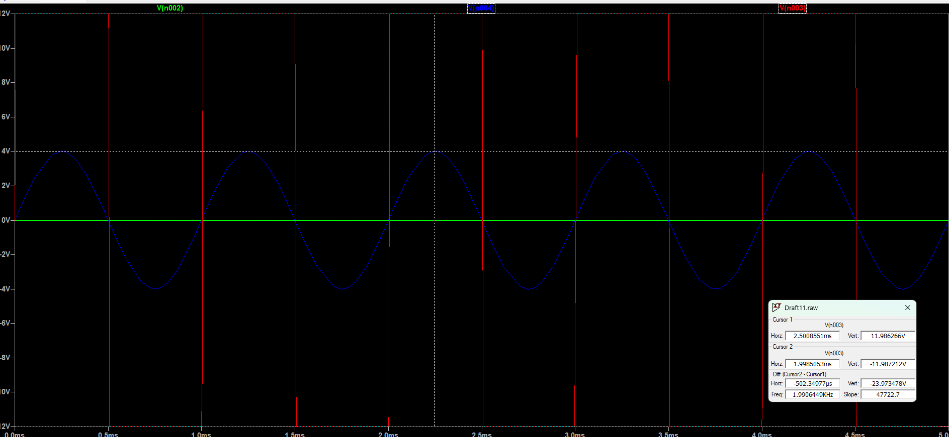
Fig. 12.5 LTspice simulated input (blue) and output (red) waveforms for V = 4 V peak, Vref = 0 V
LTSPICE CALCULATIONS
Given: V_{in} = SINE(0 4 1k), i.e. V_{max(in)} = +4 V, V_{min(in)} = −4 V, f = 1 kHz ; V_{ref} = 0 V ; supply ±12 V
V_{in(pp)} = 4 − (−4) = 8 V
From the cursors: +V_{sat} ≈ +11.99 V, −V_{sat} ≈ −11.99 V
V_{out(pp)} = 11.99 − (−11.99) = 23.98 V (cursor difference: 23.97 V)
The time between two consecutive output transitions is 502.35 µs ≈ T/2, so the output period is ≈ 1 ms (1 kHz), the same as the input. The 1.99 kHz shown by the cursor window is the reciprocal of this half-period.
The simulated saturation levels are close to the ±12 V rails, whereas the practical IC 741 saturated at +11.20 V and −9.60 V, because the real output stage loses 1–2 V of swing at each rail.

OUTCOMES:
- The working of the IC 741 operational amplifier as a zero crossing detector was studied experimentally and verified using LTspice.
- For a 4 Vpp, 1 kHz sine-wave input, a square wave of 20.80 Vpp and 1 kHz was obtained at the output, switching at every zero crossing of the input.
- The output saturated at +11.20 V and −9.60 V on ±12 V supplies, showing that IC 741 cannot swing up to its supply rails.
- Due to the very high open-loop gain, only about 56 µV of input is needed to saturate the output, so switching occurs practically at 0 V.
PRECAUTIONS:
- Keep the DC power supply in “OFF” condition while making connections.
- Do not increase the input voltage above the specification level; it may lead to damage of the IC.
- The connecting wires should not be shorted together & also check their connections with the breadboard.
- Ensure the grounds of the function generator, DSO and power supply are common.
APPLICATIONS:
- Frequency measurement by counting successive zero crossings
- Phase detection between two periodic signals
- Synchronization of electronic circuits with AC mains or other AC signals
- Sine-to-square wave conversion for digital processing
- Zero-voltage switching in AC power and motor control circuits
RESULT:
The working of Operational Amplifier IC 741 as a Zero Crossing Detector was studied and analyzed successfully using R₁ = R₂ = 1 kΩ, R_{L} = 10 kΩ and V_{ref} = 0 V. A square-wave output switching between +V_{sat} and −V_{sat} was obtained at every zero crossing of the sinusoidal input, both practically and in LTspice simulation.
FEEDBACK:
Ansh Bansal: This experiment helped me understand how an op-amp in open-loop mode works as a comparator and how a zero-volt reference converts a sine wave into a square wave.
Hardaksh Singh Sabharwal: I learned how the high open-loop gain of IC 741 drives the output into saturation whenever the input crosses zero.
Siddharth Kumar: The experiment helped me understand the difference between the practical saturation voltages and the supply voltages, and compare them with the LTspice results.
Yashika Kumari: This experiment improved my practical understanding of IC 741 circuit connections and measuring input and output waveforms using a DSO.

Signature of Faculty:

